PROJECT

ECEN-649, FALL-2019

Name: Mrinmoy Sarkar

Banner ID: 950363260

Date: 12/12/2019

Contents

Introduction 3

Description of The System 3

SAMPLER 3

COMPRESSOR 4

Uniform quantizer 4

encoder 4

Pulse generator 4

PSK Modulation 4

Channel 5

PSK demodulation 5

Decoder 6

Dequantizer 6

Expander 6

Low Pass filter 6

Design consideration for the experiment 7

Result and Discussion 8

Appendix 8

MATLAB Code 8

Plot of all signals and their spectrum 14

For G=1 14

For G=7 17

# Introduction

In this project, A voice signal is recorded using a laptop and MATLAB. The recorded voice signal is sampled, quantized, encoded and modulated using amplitude 4-ary phase shift keying (PSK) modulation technique. Then the modulated signal is sent through a channel while the signal is contaminated with additive white gaussian noise (AWGN), demodulated, decoded, dequantized to get the message signal. The received signal is passed through a low pass filter to get the original voice signal. All these analyses are done using MATLAB programming language. The overall system is described in the following sections.

# Description of The System

First a message signal is recorded with 16KHz sampling frequency, 16-bit resolution and 5 second duration using a MAC BOOK AIR laptop and MATLAB software. The audio signal is saved in a .wav file format. The message in the audio signal is **“This is ECEN649. My name is Mrinmoy Sarkar. I am doing an assigned project.”** The audio signal is then sampled with sampling frequency of 4KHz. The sampled signal is compressed with a $μ$-law compressor then quantized with uniform quantization technique. The quantized signal is encoded with 8-bit binary number and two bits are encoded in one symbol for 4-ary PSK. A pulse generator is used to generate a pulse for the encoded symbol and 4-ary PSK modulation technique is used to modulate the pulse signal. The modulated signal is amplified and transmitted through a 0.8 $σ$ AWGN channel. The noisy signal is received and integrated over the pulse width to remove the noise from the pulse signal. After integration the signal is demodulated to get the pulse signal. The regenerated pulse signal is decoded to 8-bit binary number and dequantized to voltage levels. The dequantized signal is expanded using $μ$-law expander. The expanded signal is passed through a low pass filter to get the voice signal. The received voice signal is saved in a .wav file. The block diagram of the system is shown in Figure 1. The description of the key blocks is described below.

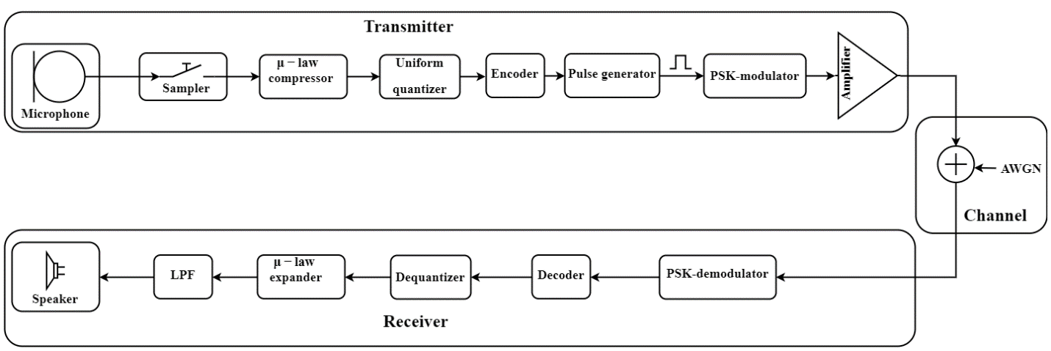

Figure 1: Block diagram of the system.

## SAMPLER

A sample is a value or set of values at a point in time. A sampler is a subsystem or operation that extracts samples from a continuous signal. A theoretical ideal sampler produces samples equivalent to the instantaneous value of the continuous signal at the desired points. If $X\left(t\right)$ is an analog continuous signal then the output of a sampler is $X\left(nT_{s}\right)$, where n is an integer number as $T_{s}$ is sampling interval. $T_{s}$ is equal to $\frac{1}{F_{s}}$, where $F_{s}$ is known to be the sampling frequency. For this project, $F_{s}$ is chosen to be 4000Hz. The output of a sampler can be calculated using the equation 1.

|  |  |  |
| --- | --- | --- |
|  |  | () |

## COMPRESSOR

For a given signal $x$, the output of the µ-law compressor can be calculated using equation 2.

|  |  |  |
| --- | --- | --- |
|  |  | () |

Where, $V$ is the maximum value of the signal $x$, µ is the µ-law parameter of the compressor, and $sgn$ is the signum function. For the project, 255 is selected as µ value.

## Uniform quantizer

Quantization, in digital signal processing, is the process of mapping input values from a large set (often a continuous set) to output values in a (countable) smaller set, often with a finite number of elements. Rounding quantization processes is used in this project. The range between the maximum and minimum value of the input signal is divided into uniform step size to make the quantization process uniform. The quantization process can be formulated as equation 3.

|  |  |  |
| --- | --- | --- |
|  |  | () |

Where, $∆$ is the uniform step size.

## encoder

The encoder converts the quantized signal into binary bits. For the project, the quantized signal is encoded into 8-bits. However, these eight bits are encapsulated as 2(log2[4])-bits as a symbol since 4-ary PSK modulation is used for the project.

## Pulse generator

In the pulse generator, the four voltage levels [0-3] have been converted as a square pulse of width T0.

## PSK Modulation

In the project 4-ary PSK or QPSK modulation technique is used. In quadrature phase shift keying, the message bits are grouped into 2-bit symbols, which are transmitted as one of four phases of a constant amplitude baseband signal. This grouping provides a bandwidth efficiency that is twice as great as the efficiency of BPSK. The general QPSK signal is expressed as equation 4.

|  |  |  |
| --- | --- | --- |
|  |  | () |

Where, $E_{s}$ is the energy per symbol and $T_{s}$ is the symbol duration.

In this QPSK constellation diagram (Figure 2), each 2-bit sequence is mapped to one of four possible states. The states correspond to phases of π/4, 3π/4, 5π/4, and 7π/4.

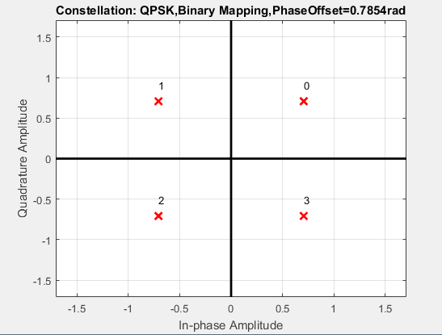

Figure 2: Constellation diagram of QPSK.

## Channel

In the channel, the modulated signal is contaminated with zero mean additive white gaussian noise.

|  |  |  |
| --- | --- | --- |
|  |  | () |

## PSK demodulation

In the demodulator, the received signal is multiplied by a reference frequency generator ($cos⁡(ω_{c}t)$) and ($sin⁡(ω_{c}t)$)) on separate arms (in-phase and quadrature arms). The multiplied output on each arm is integrated over one-bit period using an integrator. A threshold detector makes a decision on each integrated bit based on a threshold. Finally, the bits on the in-phase arm (even bits) and on the quadrature arm (odd bits) are remapped to form detected information stream. Detector for in-phase arm is shown in Figure 3. For quadrature arm the below architecture remains same but $sin⁡(ω_{c}t)$) basis function must be used instead.

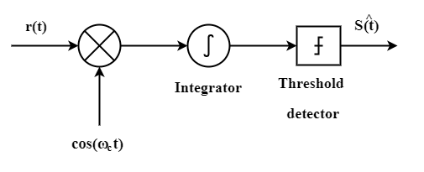

Figure 3: QPSK Demodulator In-phase arm.

## Decoder

In the decoder the demodulated signal is converted to 8-bit binary number and then converted to the corresponding decimal number.

## Dequantizer

The decoded signal is multiplied by the uniform quantization step ($∆$) to get the original quantized signal.

|  |  |  |
| --- | --- | --- |
|  |  | () |

## Expander

The µ-law expander is used to expand the dequantized signal to its original voltage level using equation 7.

|  |  |  |
| --- | --- | --- |
|  |  | () |

## Low Pass filter

The expanded signal is pass through a low pass filter, with cutoff frequency of $f_{c}=3400Hz$, to recover the original voice signal in analog form.

The filtered signal is sent to a loud speaker to understand if the voice signal is properly recognized or not.

# Design consideration for the experiment

To implement the whole system, several parameters needs to be tuned. The parameters are listed in the following table with justification.

|  |  |  |  |
| --- | --- | --- | --- |
| Name | Symbol | Value | Justification |
| µ-law parameter | µ | 255 | µ should be between 1 and 255 for the compression to happen. 255 is usually used in North America. |
| Sampling frequency | Fs | 4000 Hz | Since the voice signal is contains only human voice the maximum frequency component is less than 1000Hz, Fs should be more than 2000Hz according to Nyquist sampling theorem to avoid aliasing. |
| Quantization level | L | 256 | 256 is a standard quantization level. |
| Number of bits | n | 8 | Since, log2(L) = 8 |
| Number of voltage level for pulse signal | M | 4 | Because QPSK is used for modulation. |
| Number of bits per symbol | k | 2 | Log2(M)=2 |
| Carrier frequency | fc | 4000 Hz | For all symbol the carrier frequency is same since in PSK modulation only the phase is changed according to the symbol amplitude. |
| Amplifier gain | G | 7 | This value is selected to reduce the bit error rate to zero. |
| Cutoff frequency of LPF | fcutoff | 3400Hz | Cutoff frequency of the low pass filter is set to be 3400Hz because human voice has 0-3400hz frequency. |

# Result and Discussion

The recorded signal is transmitted successfully using sampling, non-uniform quantization and QPSK modulation through a 0.8 $σ$ AWGN channel, which is verified by MATLAB plot and by listening the received signal. Though the quality of the received signal was not as good as the original message signal, the message is clearly recognizable. The possible reason is the low sampling rate and low order of the low pass filter. There is a quantization error since only 256 level is used to quantized the analog signal. Moreover, the considered channel is quite noisy. The signal quality can be improved by increasing the sampling rate and quantization levels. The change of bit error rate (BER) with respect to Signal to noise ratio (Es/No) is shown in Figure 4. From the figure we see that if we increase the signal power before transmitting through the channel, the BER decreases.



Figure 4: Bit-error rate curve for QPSK modulation.

# Appendix

## MATLAB Code

|  |
| --- |
| %% Name: Mrinmoy Sarkar  % email: msarkar@aggies.ncat.edu    clear all;  close all;    %% record audio and save it to a file  % Fs = 16000;  % nBits = 16;  % duration = 5;  % info = audiodevinfo;  % recorder = audiorecorder(Fs,nBits,1);  % disp('Start speaking.')  % recordblocking(recorder, duration);  % disp('End of Recording.');  % y = getaudiodata(recorder);  % audiowrite('project.wav',y,Fs);      %% read a audio file  [m_sig,fs] = audioread('project.wav');  m_sig = (m_sig');  t1 = 0:1/fs:((length(m_sig)/fs)-(1/fs));  sound(m_sig,fs)  pause(5)    %% sample signal by 4kHz sampling frequency  Fs = 4000;  k = fs/Fs;  msample_sig = downsample(m_sig,k);  Ts = 1/Fs;  t = 0:1/Fs:((length(msample_sig)/Fs)-(1/Fs));    Lfft = length(t);  Lfft = 2^ceil(log2(Lfft));  M_fre = fftshift(fft(msample_sig,Lfft));  freqm = (-Lfft/2:Lfft/2-1)/(Lfft*Ts);    %% shift the level of the signal to make positive value only  bias = abs(min(msample_sig));  mshifted_sig = msample_sig + bias; % make the signal to +ve    %% quantize  Mu = 255;  no_of_bits = 8;  M = 4;  T0 = 1; %width of the pulse  V = max(abs(mshifted_sig));  comp_sig = compand(mshifted_sig, Mu, V,'mu/compressor');  delta = (max(comp_sig)-min(comp_sig))/(2^no_of_bits-1);  [q_sig_t,q_sig] = uniform_quantize(comp_sig,no_of_bits);    %% code the signal to symbol  [code_sig,code_bin] = encode(q_sig,no_of_bits,M);  Fs1 = Fs*no_of_bits/log2(M);  t_code = 0:1/(Fs1):(length(code_sig)/Fs1 - 1/Fs1);    %% create pulse for the symbol  pulsewidth = (T0*log2(M))/(Fs*no_of_bits);  fprintf('The pulse width is : %.2f ms. \n',pulsewidth*1000);  pulse_sig = generatePulse(code_sig,T0);  Fs2 = Fs1*T0;  t_pulse = 0:1/(Fs2):(length(pulse_sig)/Fs2 - 1/Fs2);    %% psk modulation  psk_sig = pskmod(pulse_sig,M,pi/4);    %% add noise  G = 7;  sig = 0.8;  Es = mean(abs(pulse_sig).^2)*G;  No = 2*sig^2;  EsNodB = 10*log10(Es/No);  awgnchan = comm.AWGNChannel;  awgnchan.NoiseMethod='Signal to noise ratio (Es/No)';  awgnchan.EsNo = EsNodB;  noisy_sig = awgnchan(psk_sig);    %% integrate over the pulse width  int_sig = integrate(noisy_sig,T0);    %% psk demodulation  demod_sig = pskdemod(int_sig,M,pi/4);    %% decode signal  [decode_sig,decode_bin] = decode(demod_sig,M);    %% dequantize  deq_sig = decode_sig.*delta;    %% uncompress  uncom_sig = compand(deq_sig,Mu,V,'mu/expander');    %% remove bias  unbiased_sig = uncom_sig - bias;    %% Low pass filter design  B_m = 3400; %cutoff frequency  h = fir1(256, B_m*Ts);  recv_sig = filter(h,1,unbiased_sig);  sound(recv_sig,Fs)  audiowrite('project_recv.wav',recv_sig,Fs);    Lfft_recv = length(t);  Lfft_recv = 2^ceil(log2(Lfft_recv));  recv_fre = fftshift(fft(recv_sig,Lfft_recv));  freqm_recv = (-Lfft_recv/2:Lfft_recv/2-1)/(Lfft_recv*Ts);    [number,ratio] = symerr(code_sig,demod_sig);  fprintf('No. of symbol missed %d and symbol error rate %f.\n',number,ratio);  [numberb,ratiob] = biterr(code_bin, decode_bin);  fprintf('No. of bit missed %d and bit error rate %f.\n',numberb,ratiob);      %% plot  figure(1)  subplot(3,1,1)  plot(t1,m_sig)  ylabel('m(t)','FontSize', 16)  xlabel('t(sec)','FontSize', 16)  title('Message signal','FontSize', 16)  ax = gca;  ax.FontSize = 16;    subplot(3,1,2)  plot(t,msample_sig)  ylabel('m(T)','FontSize', 16)  xlabel('T(sec)','FontSize', 16)  title('Sampled message signal','FontSize', 16)  ax = gca;  ax.FontSize = 16;    subplot(3,1,3)  plot(t,comp_sig)  ylabel('m_{compressed}(T)','FontSize', 16)  xlabel('T(sec)','FontSize', 16)  title('Compressed message signal','FontSize', 16)  ax = gca;  ax.FontSize = 16;    figure(2)  subplot(3,1,1)  plot(t,q_sig_t)  ylabel('m_{quantized}(T)','FontSize', 16)  xlabel('T(sec)','FontSize', 16)  title('Quantized message signal','FontSize', 16)  ax = gca;  ax.FontSize = 16;    subplot(3,1,2)  plot(t_code,code_sig)  ylabel('m_{code}(T)','FontSize', 16)  xlabel('T(sec)','FontSize', 16)  title('Coded message signal','FontSize', 16)  ax = gca;  ax.FontSize = 16;    subplot(3,1,3)  plot(t_pulse,pulse_sig)  ylabel('m_{pulse}(T)','FontSize', 16)  xlabel('T(sec)','FontSize', 16)  title('Pulsed message signal','FontSize', 16)  ax = gca;  ax.FontSize = 16;    figure(3)  subplot(3,1,1)  plot(t_code,demod_sig)  ylabel('m_{demod}(T)','FontSize', 16)  xlabel('T(sec)','FontSize', 16)  title('Demodulated message signal','FontSize', 16)  ax = gca;  ax.FontSize = 16;    subplot(3,1,2)  plot(t,decode_sig)  ylabel('m_{decode}(T)','FontSize', 16)  xlabel('T(sec)','FontSize', 16)  title('Decoded message signal','FontSize', 16)  ax = gca;  ax.FontSize = 16;    subplot(3,1,3)  plot(t,deq_sig)  title('dequantize signal')  ylabel('m_{dequantized}(T)','FontSize', 16)  xlabel('T(sec)','FontSize', 16)  title('Dequantized message signal','FontSize', 16)  ax = gca;  ax.FontSize = 16;    figure(4)  subplot(2,1,1)  plot(t,uncom_sig)  ylabel('m_{uncompressed}(T)','FontSize', 16)  xlabel('T(sec)','FontSize', 16)  title('Uncompressed message signal','FontSize', 16)  ax = gca;  ax.FontSize = 16;    subplot(2,1,2)  plot(t,recv_sig)  ylabel('m_{recv}(T)','FontSize', 16)  xlabel('T(sec)','FontSize', 16)  title('Received message signal (after low pass filter)','FontSize', 16)  ax = gca;  ax.FontSize = 16;    figure(5)  subplot(2,1,1)  plot(freqm,abs(M_fre))  ylabel('M(f)','FontSize', 16)  xlabel('f(Hz)','FontSize', 16)  title('Spectrum of message signal','FontSize', 16)  ax = gca;  ax.FontSize = 16;    subplot(2,1,2)  plot(freqm_recv,abs(recv_fre))  ylabel('M_{recv}(f)','FontSize', 16)  xlabel('f(Hz)','FontSize', 16)  title('Spectrum of received signal','FontSize', 16)  ax = gca;  ax.FontSize = 16;      scatterplot(psk_sig)  title('4-ary PSK modulated signal','FontSize', 16)  ax = gca;  ax.FontSize = 16;  ax.Children.MarkerSize = 70;    scatterplot(noisy_sig)  title('Received noisy signal','FontSize', 16)  ax = gca;  ax.FontSize = 16;    %% helper functions    function [yt,yq]=uniform_quantize(x,no_of_bits)  del = (max(x)-min(x))/(2^no_of_bits-1);  yt = zeros(1,length(x));  yq = zeros(1,length(x));  for i=1:length(x)  yt(i) = del*round(x(i)/del);  yq(i) = round(x(i)/del);  end  end    function [ys,yb]=encode(x,n,M)  k = log2(M);  ys = zeros(1,length(x)*k);  yb = [];  indx = 1;  for i=1:length(x)  bincode = dec2bin(abs(x(i)),n);  yb = [yb de2bi(abs(x(i)),n,'left-msb')];  for j=1:k:n  code = bincode(j:j+k-1);  ys(indx) = bin2dec(code);  indx = indx + 1;  end  end  end    function [y,yb]=decode(x,M)  k = log2(M);  n = k*M;  y = zeros(1,length(x)/M);  indx = 1;  yb = [];  for i=1:length(y)  bincode='';  for j=1:M  bincode = strcat(bincode,dec2bin(x(j-1+indx),k));  end  indx = indx+M;  y(i) = bin2dec(bincode);  yb = [yb de2bi(abs(y(i)),n,'left-msb')];  end  end    function y=generatePulse(x,k)  y = zeros(1,length(x)*k);  indx = 1;  for i=1:length(x)  for j=1:k  y(indx) = x(i);  indx = indx + 1;  end  end  end    function y=integrate(x,k)  y = zeros(1,length(x)/k);  indx = 1;  for i=1:k:length(x)-k+1  y(indx) = sum(x(i:i+k-1));  indx = indx+1;  end  end |

## Plot of all signals and their spectrum

### For G=1











### For G=7











